Adding New Item/Spell/Achievement Icons

Every blizzard spell, item, achievement, and skill has an icon. They all have the same basic template:



Sized down to 64x64 resolution.  
  
So all you need to do is open photoshop/gimp/whatever you have and paste in your chosen image, then put the template over it, size it down to 64x64, change it to indexed colour mode, and save it as a .png.

Breakdown:  
Paste in your chosen image:

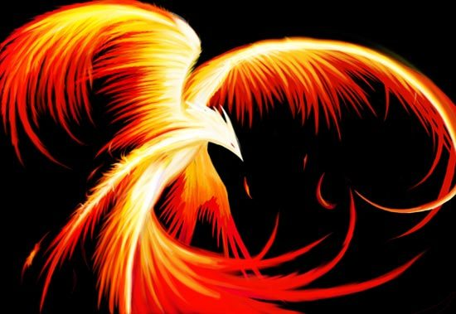

This is just a picture I pulled off of google. I pasted it in to Photoshop and put the template over it like so:

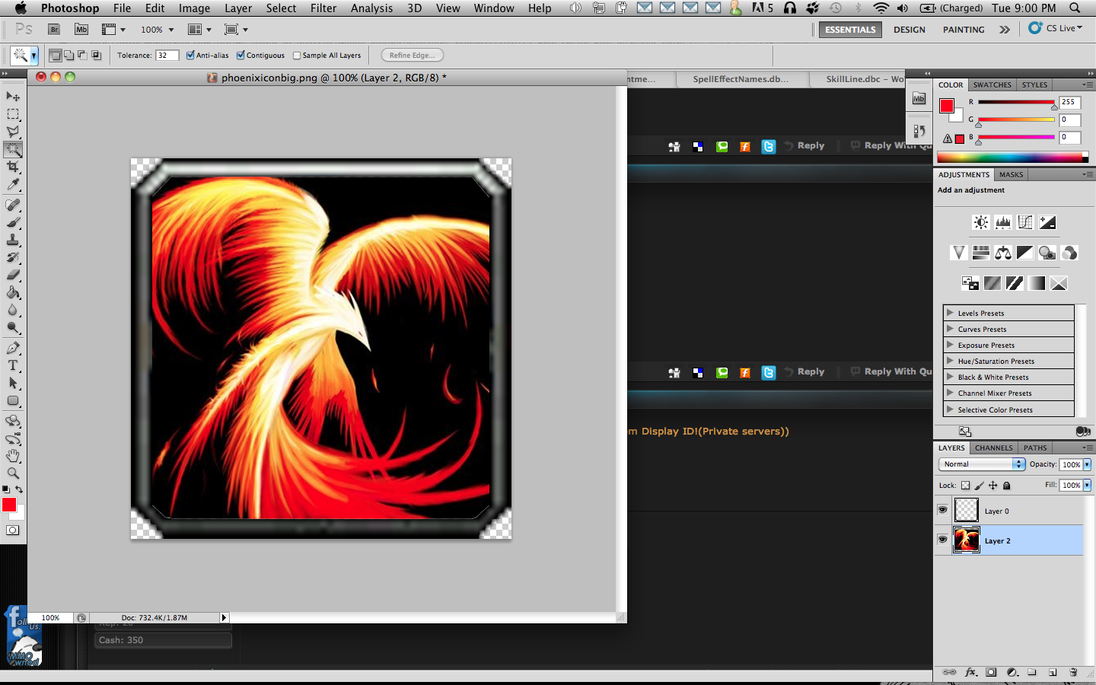

Then I resize it to 64x64 resolution and set the color mode to INDEXED. In Photoshop that's Image>Mode>Indexed Color. Then make sure you click "Web" under the Forced Color dropdown menu:

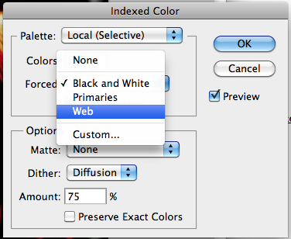

The result:

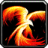

Now you just need to convert the image to a .blp. This is Blizzard's image format.  
Use this java converter to do so:  
[WoWImage](http://www.megaupload.com/?d=OKUXFGI3)  
Just drag and drop the file onto the "Encode" button.  
  
  
Well, I hope this guide helped you. I will be adding to it until it's complete, and then I will go about improving it if there are any problems. There just aren't enough good DBC guides out there. Comment or PM me for any particular requests that you would prefer for me to complete first!